Quantum Computing Capstone Project
By: Hanwen Xing, Matteo Johnson, and Anthony Gelasi

1. Project Overview
We focused on exploring quantum computing techniques for solving optimization problems. During the first semester, our team gained foundational knowledge in quantum computing topics, including quantum circuits, fundamental algorithms, and basic Qiskit implementation. The project followed a structured workflow consisting of weekly study, discussion, and implementation activities
At the beginning of the second semester, the project has transitioned from theoretical learning toward practical applications and is ready for more advanced work.

2. Current Semester Focus
In this semester, the team is participating in the IBM quantum course, which emphasizes hands-on experience with quantum programming using IBM Quantum and Qiskit tools.
Our primary goals for this phase include:
- Strengthening practical skills in quantum circuit construction
- Understanding variational quantum algorithms
- Implementing optimization algorithms such as QAOA
- Preparing a demonstrable final product, such as a website showing our work

3. Work Completed This Semester

3.1 Workshop Learning Progress
Our team has completed the first three workshop assignments during the winter break and the first few weeks of this semester:
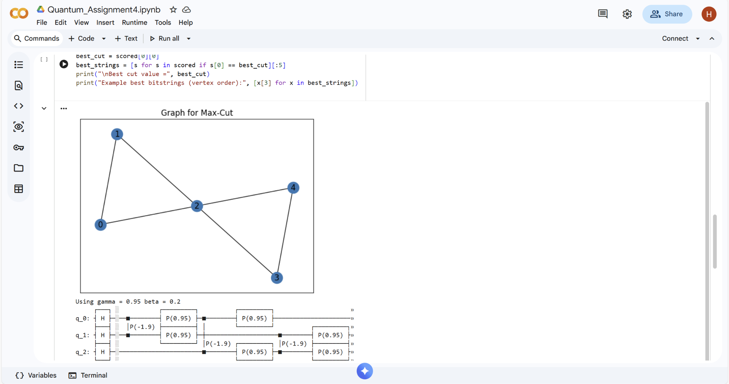Quantum_Assignment4.ipynb
Assignment 1 — Quantum Gates
We studied matrix representations of quantum gates and verified important identities such as Pauli gate relationships and tensor products, which helped to reinforce our understanding of multi-qubit operations
Assignment 2 — Simple Quantum Circuit Execution
We constructed and executed basic quantum circuits using IBM’s quantum computing platform, gaining experience in gate placement, measurement, and interpreting output results. These were run on quantum computer instances across the country (real circuit deployments).
Assignment 3 — QAOA Gate Construction
We analyzed the mathematical definitions of QAOA cost and mixing operators 𝑈(𝐶,𝛾)U(C,γ) and 𝑈(𝐵,𝛽)U(B,β), and computed these gates for small quantum systems, building a deeper theoretical understanding of variational algorithms

3.2 Current Work — Assignment 4
Our team is halfway through Assignment 4, which involves implementing the Quantum Approximate Optimization Algorithm (QAOA) to solve the Max-Cut problem using Qiskit. This task requires Translating theoretical QAOA operators into executable quantum circuits, Implementing the algorithm for small graph optimization problems and Running simulations using IBM Quantum Lab. This assignment represents a key transition from theoretical learning to practical applications in our quantum algorithm development. We plan to present our implementation results and discuss optimization strategies during the next project meeting.

4. Project Development Plan
Beyond coursework, our team is actively planning the final deliverable for the project. Our goal is to create a product that effectively demonstrates our work to a broader audience.
Currently, we propose developing an interactive website that will:
- Explain fundamental quantum computing concepts in an accessible language
- Demonstrate QAOA and optimization examples
- Display visualizations of quantum circuits and results(jpg, not interactive on this)
- Showcase our project progress and findings
- Practical Applications of our findings
This approach aligns with our objective of creating a practical and educational demonstration and elaborating our web design skills. (ps: Some of our group members took web design courses.)

5. Next Steps
In the coming weeks, the team will focus on discussing the QAOA application and analysis of the “Max-Cut” problem, deciding whether we are going to make the website or not, as well as preparing more documentation and ready for assignment 4’s discussion.

6. Conclusion
At the start of the second semester, the project has successfully progressed from foundational learning to applied quantum algorithm development. The completion of our initial workshop assignments demonstrates growth in both our theoretical knowledge and practical skills.
The upcoming QAOA implementation and website development will represent another milestone as the project moves toward sprint8.

